An example of a short Book Talk on The Graveyard Book by Neil Gaiman:

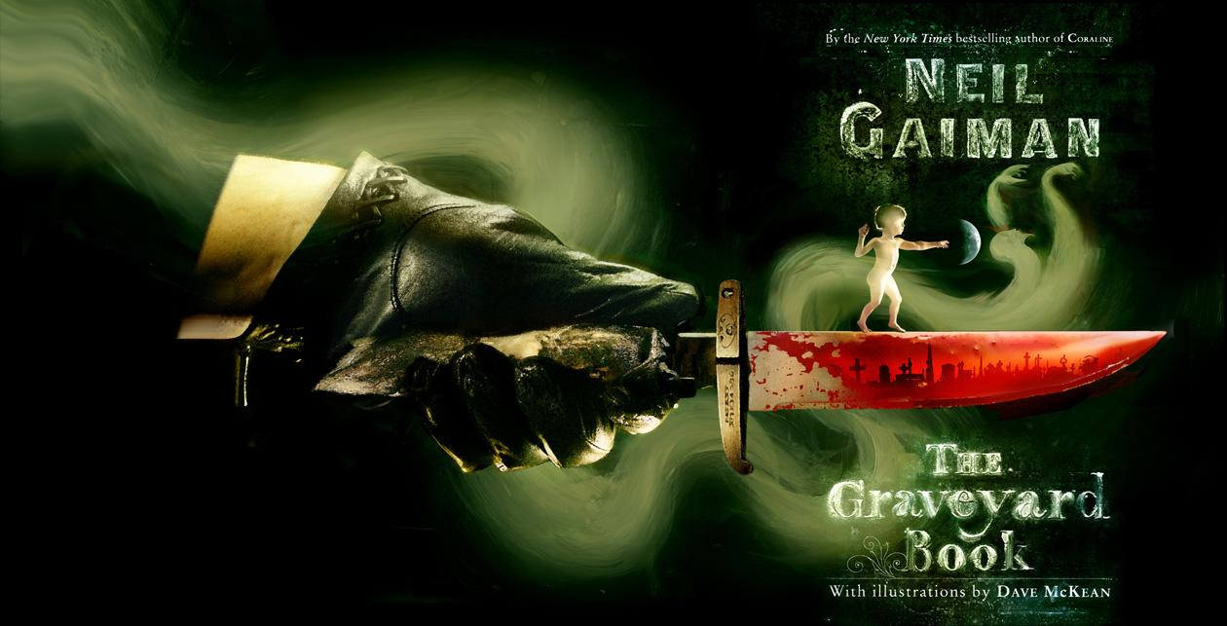
(Attention-Getter)
“There was a hand in the darkness, and it held a knife.”
(Intro)
The Graveyard Book is a fictional novel by Neil Gaiman, who also wrote Coraline.
(Body)
In this book, Neil Gaiman tells the story of Nobody Owens, known as Bod. On the night his parents are brutally murdered, 2 year old Bod calmly climbs out of his crib and toddles out of the house and into a nearby cemetery. There he is adopted by Mr. and Mrs. Owens (childless and dead for 250 years!) who gladly care for the child and protect him from harm.
With loving ghostly parents, teachers, friends, and protectors, Bod grows from age two to fifteen in the graveyard. He learns to read and do numbers, and he also learns some ghostly skills. But not all the residents of the graveyard are friendly. There are witches, ghouls and creatures and let’s not forget Jack – the evil fiend who is out to finish the job he started.
(Conclusion)
Filled with great illustrations, this is a funny, exciting and suspenseful story. How will Bod survive? Or will he? Can his loving family and friends really protect him from the evil Jack? This delightfully gruesome and very English tale will certainly appeal to both boys and girls who like adventure stories, suspense and some action. The Graveyard Book won the Newbery Award in 2009, and the awards said that the book is a “delicious mix of murder, fantasy, humour and human longing,” according to Diane Ferbrache, Hazen High School Librarian for The Washington Evergreen Young Adult Book Award, 2011

