Beach Park Middle School Library Digital Media Circulation

APPROVAL FORM

A collection of Playaway digital audio books and MP3 audio books are part of our middle school library collection. Students are encouraged to borrow library Playaways and MP3 players for home use. For safety reasons, students will need to use their own headphones or ear buds. Ear buds will be available for purchase from the school store.

Playaways are electronic devices with a book pre-loaded on it. There are pause, fast forward, rewind and volume control buttons. They run on batteries.

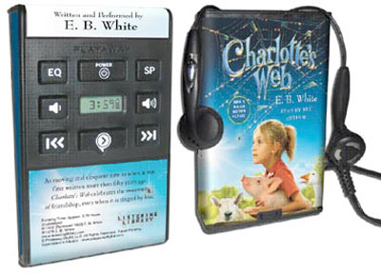

If students would like to check out an MP3 player, they will need to first choose what book they would like loaded on that MP3 player from Destiny http://destiny.bpd3.org. Once they inform the library staff, the student should check back during homeroom to see if it has been loaded.

Because of the expense involved with replacing lost or damaged Playaways and MP3 players (average cost $60.00), we are asking parents to sign the attached permission slip giving your child permission to check out these digital media from the middle school library. Once this slip is returned, then a note will go into Destiny, and your student will be allowed to check out digital media. This is a one-time permission slip throughout your child’s career at our middle school. If you wish to stop this privilege, please contact the library and we will adjust our records.

Thank you.

Jeanné Aken
Beach Park Middle School Library
jaken@bpd3.org
847-596-5880

Student NAME, GRADE and TEAM ____________________________________________________________________

I give my child permission to check out Playaway digital audio books and MP3 players with an audio book loaded on it from the middle school library. I understand that the replacement cost for lost or damaged Playaways or MP3 players is $60.00 and is the responsibility of my child.

Parent/Guardian Signature _________________ ___________________________ Date _________________________

